**Sean Poston**

**4/6/2020**

**CY201 Basic Network Commands**

**Lab:**

**Ping Google/Gogl:**

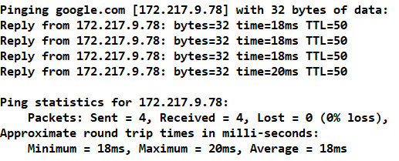

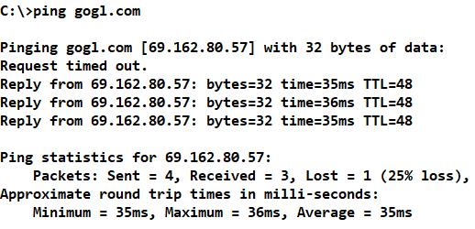

**IPConfig:**

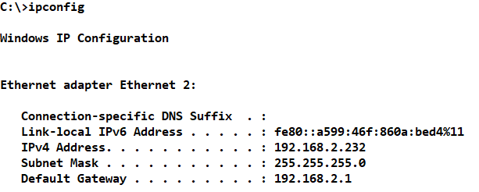

**Tracert:**

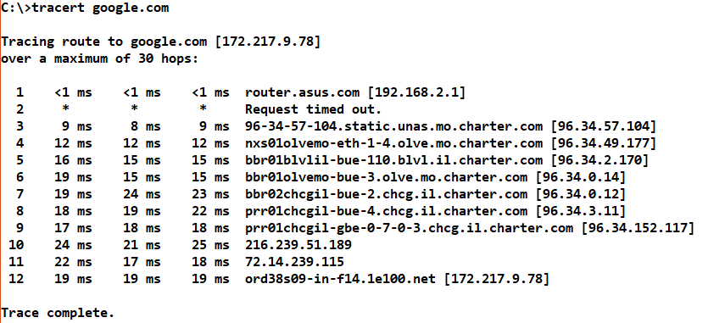

**Netstat:**

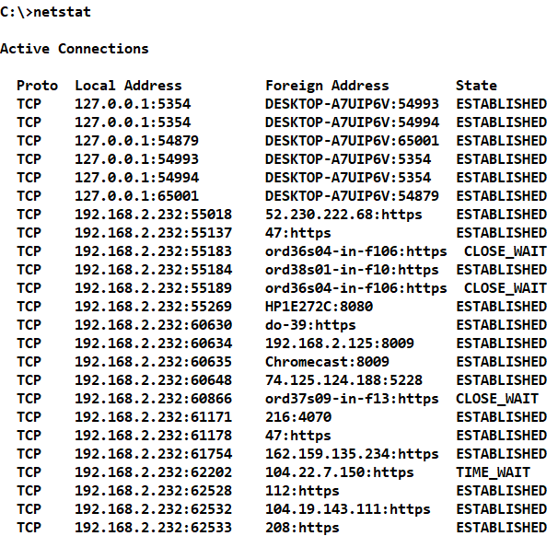

**ARP -a:**

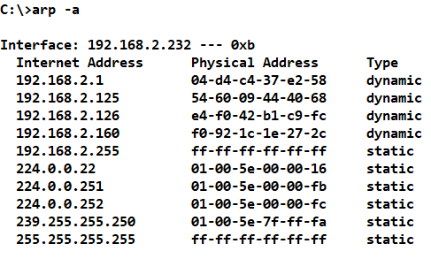

**NSLookup Google:**

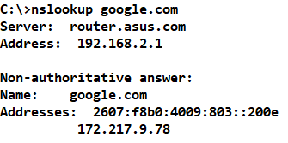

**Post-Lab Questions:**

1. Which command – line utility program is used to find the primary DNS suffix, IP v4 and IP v6 addresses for your computer?

**IPConfig /all**

1. The --------------- command causes a data packet to be sent to a specific IP address and then returns to the initiating machine.

**Ping**

1. Which command detects whether routers along a communication path are functioning?

**Tracert**

1. Which utility program is used to examine current network connections?

**NETSTAT**

1. The ---------------------- utility is used to map IP addresses to MAC address.

**ARP**

1. Which utility command is used to examine a list of all the shared devices on a LAN?

**net view**